 | Association | Upcoming Events | About event | Dates and venue | Deadlines | Fee
1. | Association of Medical Education in Europe (AMEE) - Ассоциация медицинского образования в Европе | First World Summit on Competency-Based Education  http://www.amee.org/conferences/amee-2016/world-summit-on-competency-based-education#registration  AMEE Barcelona 2016  https://www.eiseverywhere.com/ehome/amee2016/registration-fees/  AMEE 2017  http://www.amee.org/conferences/amee-future-conferences | One of the most important trends in the last decade has been the move to competency-based/outcome-based education. The summit, organized by the International Competency Based Medical Education Collaborators (ICBMEC), provides a forum for experienced individuals or those new to the theme to share information and innovations and to explore further developments in the field. The summit will include plenary sessions, short communications, poster presentations and ‘how-to’ workshops.  Innovating in Education.  Conference themes include:  Responding to challenging circumstances  Justifying the costs of innovation  Decision-making in a complex environment | on 27th and 28th August 2016  Barcelona, Spain  27-31 August 2016 to be held in Barcelona, Spain  Venue and Location to be decided |  | €460  €695
2. | European Universities Association (EUA) -  Европейская Ассоциация Университетов  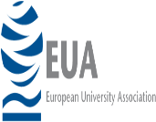 | 3rd EUA Funding Forum  Efficient universities: Value for society  http://www.eua.be/activities-services/events/event/2016/10/06/default-calendar/3rd-funding-forum  11th European Quality Assurance Forum  http://www.eua.be/activities-services/events/event/2016/11/17/default-calendar/11th-european-quality-assurance-forum | The Funding Forum is a unique, inclusive platform open to all higher education funding stakeholders – universities and students, public authorities, public and private funders and partners.  Quality in context – embedding improvement  The European Quality Assurance Forum (EQAF) provides a platform for discussion, professional development and exchange of experiences among the main stakeholders in quality assurance (QA). | 6 - 7 October 2016  Hosted by University of Porto, Porto, Portugal  17 - 19 November 2016  Hosted by the Slovenian Student Union / University of Ljubljana, Ljubljana, Slovenia | The deadline to submit contributions is 25 July 2016. | 325 Euro
3. | International Pharmaceutical Federation (FIP) -Международная Фармацевтическая Ассоциация 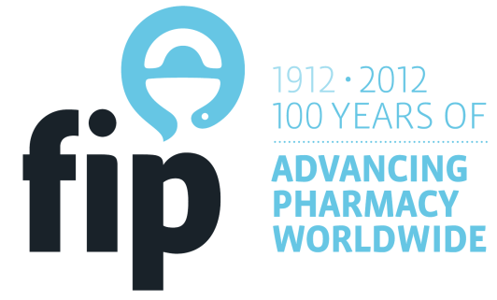 | 76th FIP World Congress of Pharmacy and Pharmaceutical Sciences 2016  http://www.fip.org/buenosaires2016/ | Rising to the challenge: reducing the global burden of disease | 28 August - 1 September 2016  Buenos Aires, Argentina |  | Regular fee (non member)  € 1000
4. | Association of Dental Education in Europe (ADEE) - Ассоциация Стоматологического образования в Европе | Annual Meeting 2016  http://www.adee.org/  Joint ADEE/ADEA Meeting  http://www.adee.org/meetings/london2017/index.html  Vilnius, Lithuania | Sience and the competent dentist: an inter-professional perspective.  http://www.adee.org/meetings/barcelona2016/programme.html  An interactive two day workshop dedicated to international leaders of dental education | 24-27 August 2016  Barcelona, Spain  8-9 May 2017  London  Date to be confirmed | Early bird registration has been extended to 15th June 2016 | ADEE Member  €345  ADEE non-member  €450  to be confirmed
5. | European Association of Faculties of Pharmacy (EAFP) - Европейская Ассоциация фармацевтических факультетов | 2017 Annual Conference Helsinki, Finland  http://eafponline.eu/conferences/conferences-in-europe/ |  |  | Early bird (before April 8) | EAFP members-175,  Non-EAFP members-350,  Students-100
6. | Association of Medical Schools in Europe (AMSE) - Ассоциация медицинских школ в Европе | "Challenges of doctor mobility in a changing Europe - Standards and recognition for patient safety”  http://www.amse-med.eu/sub/conferences |  | 7 October 2016,  Prague | 2015 | Members-200 Euro, Non-members-250 Euro, Students-100 Euro
7. | Association of Schools of Public Health in the European Region (ASPHER) - Ассоциация школ общественного здравоохранения в Европейском регионе | http://aspher.org/
8. | Organization for PhD Education in Biomedicine and Health Sciences in the European System (ORPHEUS) - Организация PhD образования по биомедицине и медицинских наук в Европейской системе | Dubrovnik International  Bioethics Summer School – DIBSS  ORPHEUS Ethics in Science Module.  http://www.orpheus-med.org/images/stories/documents/Modul%20ORPHEUS%20Dubrovnik%20annonucemnet%20web%20page.pdf | Topics:  1. Ethics and Scientific Research  2. Scientific Misconduct  3. Publication Ethics Issues  4. Practice Examples- How to Teach Ethics in Science  5. Round table discussion- Can we create a pledge like Hippocratic Oath for ethics in  science for young researchers? | From the August 4th to the August 15th 2016 Dubrovnik, Croatia
9. | Eurasian Universities Union (EURAS) - Союз Евразийских Университетов  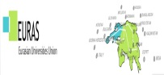 | EURIASIA HIGHER EDUCATION SUMMIT - EURIE 2017  http://eurieeducationsummit.com/ | Themes:  Internationalization strategy and performance,  Mobility of students, instructors and researchers,  Regional cooperation and harmonization,  Changing trends in higher education. | will be held in Istanbul, Turkey | Exhibitor registration opens: June 1, 2016  Online participant registration opens: October 1, 2016  Early bird participant registration deadline: December 31, 2016  Exhibitor registration deadline: February 2017 | Contact: eurie@eurieeducationsummit.com
10. | United Nations Academic Impact (UNAI) – Инициатива ООН «Взаимодействие с академическими кругами» (ЮНАИ) | 66th UN DPI/NGO Conference  http://outreach.un.org/ngorelations/conference-2016/registrationinstructions/ |  | From 30 May to 1 June, 2016  in Gyeongju, Republic of Korea

